**The Eric Brown Award 2017**

**Eric Brown Award was presented to Gerry Hermer AFC**

Gerry Hermer AFC, one of East Anglian Air Ambulance’s (EAAA) founding members, fully retired in March this year after nearly 50 years in rotary aviation!

Gerry was the driving force behind the establishment of the Air Ambulance and Police flight in East Anglia; not only did his drive, passion and determination inspire others to set up both services, but his professional expertise, aviation knowledge and acumen help shape the EAAA into one of the most advanced and sophisticated Air Ambulance units in the UK.

Formally as an RAF Search and Rescue Pilot (AFC), and latterly as an Air Ambulance pilot, Flight Operations Manager, Managing Director and founder of Sterling Helicopters, Gerry has offered his first class flying expertise and understanding at all levels of the operation. As a junior pilot flying SAR missions in the RAF and as an instructor and examiner within civil aviation he has continuously strived to develop the skills and procedures of crews on operations. Gerry has further represented the helicopter industry through the Air Ambulance Association and the British Helicopter Association with his involvement in governance and policy development of HEMS.

Gerry is well known throughout the industry, earning respect and admiration for his remarkable achievements. His attention to detail, aviation knowledge and clear focus on safety and procedure has earned him an enviable reputation.

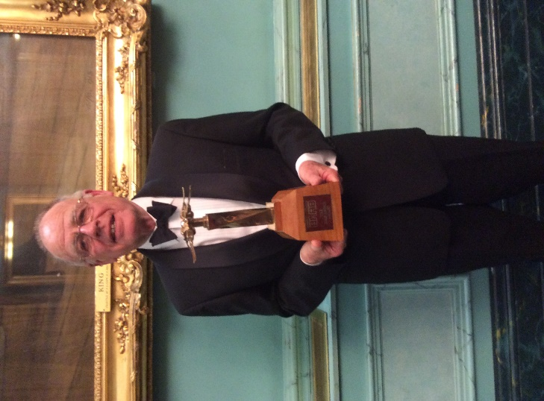 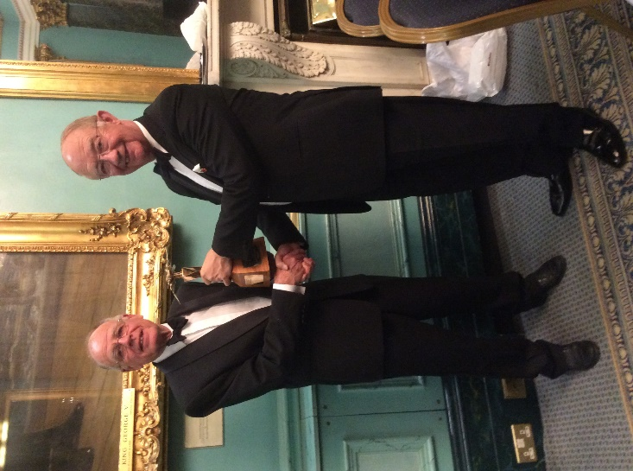

*Gerry Hermer AFC Sir Christopher Coville presenting the award to Gerry*